Sujeto/Subject: Reporte de Accidente / Accident report

|  |  |  |  |
| --- | --- | --- | --- |
| **Datos de la victima / Victim's personal information** | | | |
|  | | | |
| Nombre/Name: | | | |
| Apellido/Last Name: | | | |
| Nacionalidad/Nationality: | | | Pasaporte/Passport: |
| Edad/Age: | Genero/Gender: | | N° Cel/Phone n°: |
| Direccion/Adress: | | | |
| Seguro/Insurance: | | Poliza del Seguro n°/Insurance police n°: | |
| **Persona de contacto / Person to inform:** | | | **via (Tel/E-mail):** |
| **Descripcion de los hechos / Accident description** | | | |
| Donde/Where:  Coordenadas/GPS Coordinate: | | | Montaña/Mount:  Ruta/Route:  Altura/Altitude: |
| Cuando/When: | Hora/Hour: | | Fecha/Date: |
| Tipo de accidente/ Type of accident: |  | | Numero de victimas/Number of victims: |
| Que paso/What happend: | | | |
| Herridas/Injuries : | | | |

Sincerely Group of Mountain Rescue of Peru “Socorro Andino Peruano S.A.P”

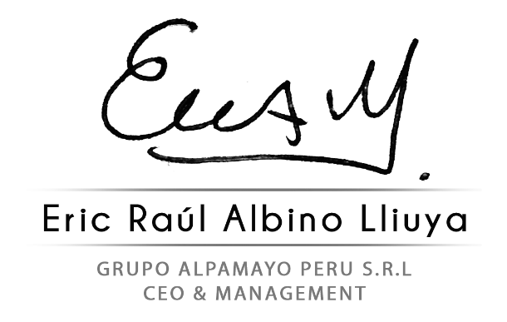

Socorro Andino Peruano S.A.P



Socorro Andino Peruano S.A.P

DNI: 73693471 DNI: 42566926

Gerente General CEO - Fundador